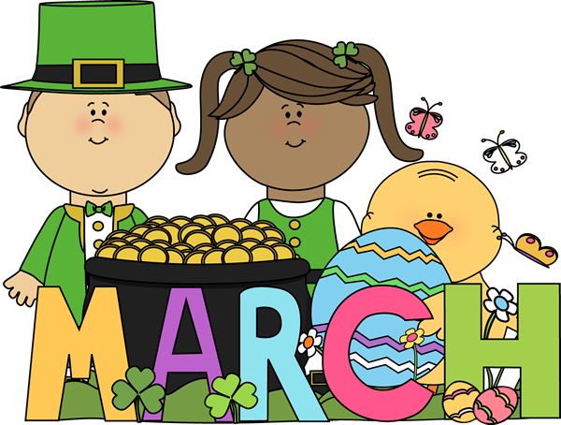

Mrs. Rogge’s March Snack Calendar
- Please send enough pre-portioned snacks for 20 scholars. Thank you!
- Your child will also be the classroom “Noodle Master” on this day!

Sunday | Monday | Tuesday | Wednesday | Thursday | Friday | Saturday
3 | 4  Grace | 5  Leo | 6  Huck | 7  Ben | 1  Hattie  Vera  8 | 9
10 | 11  Louis | 12  Happy B-day  Gus | 13  Addy | 14  William | 15  Calista | 16
17 | 18  Keagan | 19  Zana | 20  Ella | 21  Virtue Assembly  9:00am  Gretchen | 22  No School | 23
24 | 25 | 26  Spring Break! NO SCHOOL! Spring Break! | 27 | 28 | 29 | 30
31 | April 1  Davis | 2  Amira | 3  Gabriel | 4  Vinny | 5  Happy B-day  Hattie | 6
7 | 8  Elisa | 9  Grace | 10  Leo | 11  Huck | 12  Ben | 13

